**Surabhi Asati**

**STAT – 6610**

**Homework assignment-3**

1. **Do you want to work as an Application User, Scripter, or Hacker? Read**[**Enterprise Data Analysis and Visualization: An Interview Study**](http://vis.stanford.edu/files/2012-EnterpriseAnalysisInterviews-VAST.pdf)**by Kandel, Paepcke, Hellerstein, Heer**
2. **From the FollowingData website read a**[**Project**](http://flowingdata.com/category/projects/)**that uses maps. Explain what the project was about and what data was used. Summarize the information being presented in the maps.**

Project Name: Where Bars Outnumber Grocery Stores

Project link: <http://flowingdata.com/2014/05/29/bars-versus-grocery-stores-around-the-world/>

Chart Type used: Dot Map - Each dot represents a data point. Collectively, geographic patterns emerge.

About the Project: The Project is based on a study aimed at binary comparison of the number of bars to the number of grocery stores across the United States. Conducted by the Floating.sheep group in 2008 with data collected from now defunct google Maps directory. <http://www.floatingsheep.org/2010/02/beer-belly-of-america.html>

Objective of the Project is to map the magnitude of difference in areas with either more bars or more grocery stores across United states and other countries.

Data Used: Geographic locations of bars and grocery stores in USA (and in some other Countries) from Google Places API

Summary:

The author pulled data from Google Places API, checked along every 20 miles and then searched within a 10-mile radius for bars and grocery stores and converted into ratios. Below is the map of United States. The more bars, the darker the brown and the more grocery stores, the darker the green.

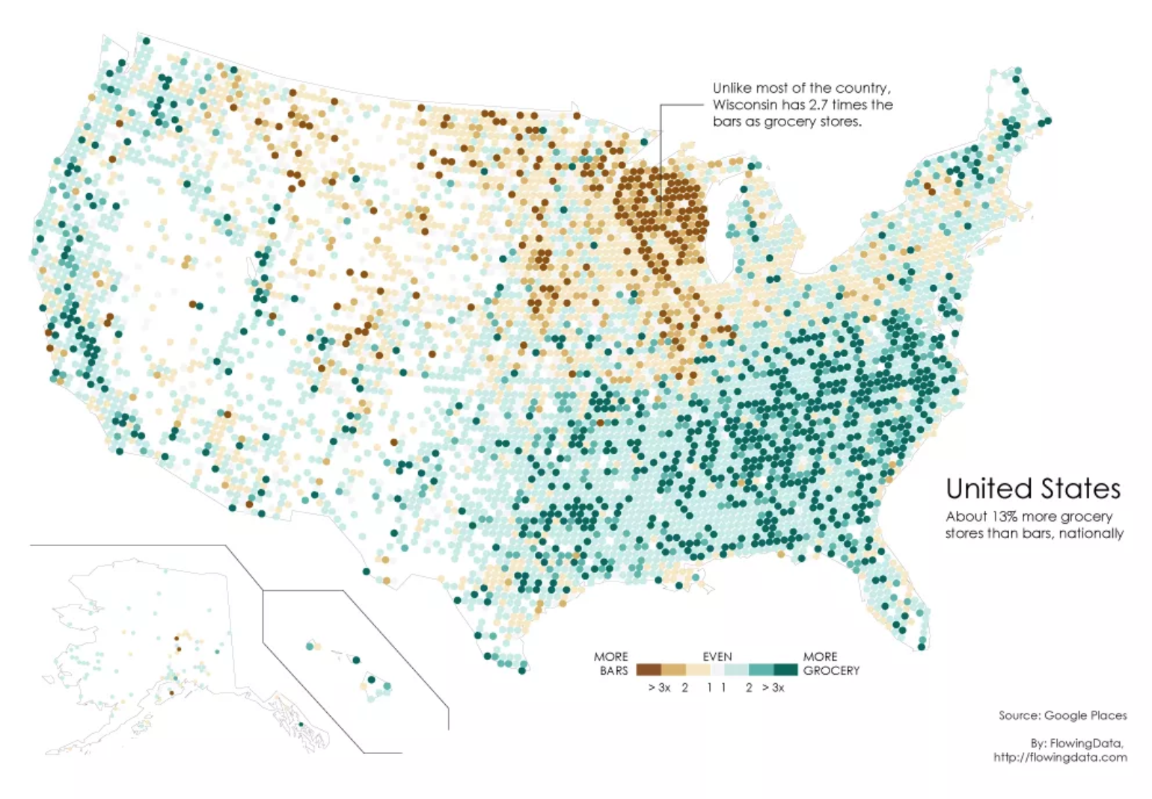

Clearly, there is a high bar concentration in Wisconsin (The Beer Belly of America), whereas a lot of the country has at least three times more grocery stores (demonstrated in floating.sheep’s study)

The Author points out that the bars versus grocery stores comparison says more about culture than anything else because:

* Higher bar rates don’t necessarily point to higher volumes of drinking. This can be verified by considering [drinking estimates from the World Health Organization or OECD](http://en.wikipedia.org/wiki/List_of_countries_by_alcohol_consumption) for comparisons.
* Also, these numbers aren’t from official government records, so it is assumed that data from Places API is accurate.
* Finally, the per capita rates here are probably higher than from government records, because places can have multiple place types. For example, a hotel/restaurant with a bar can be counted as bars, which is different from places that solely serve liquor.

Bars Vs Grocery Stores Map of some other countries:

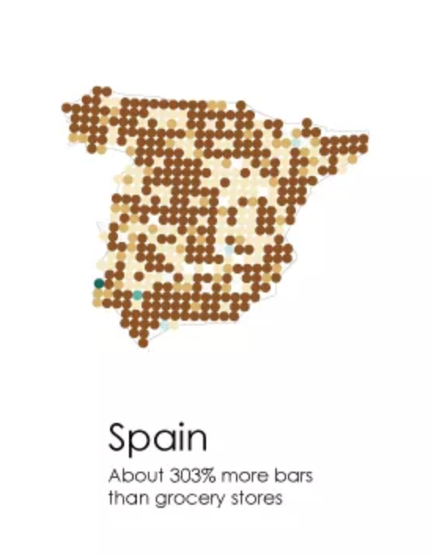 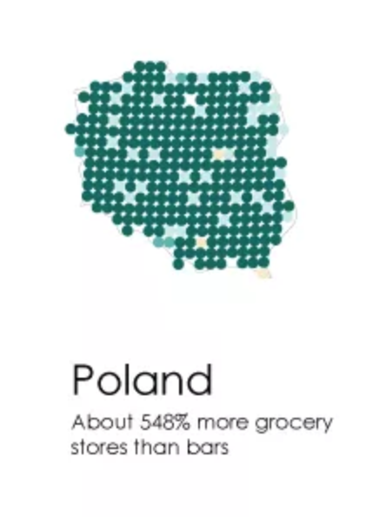

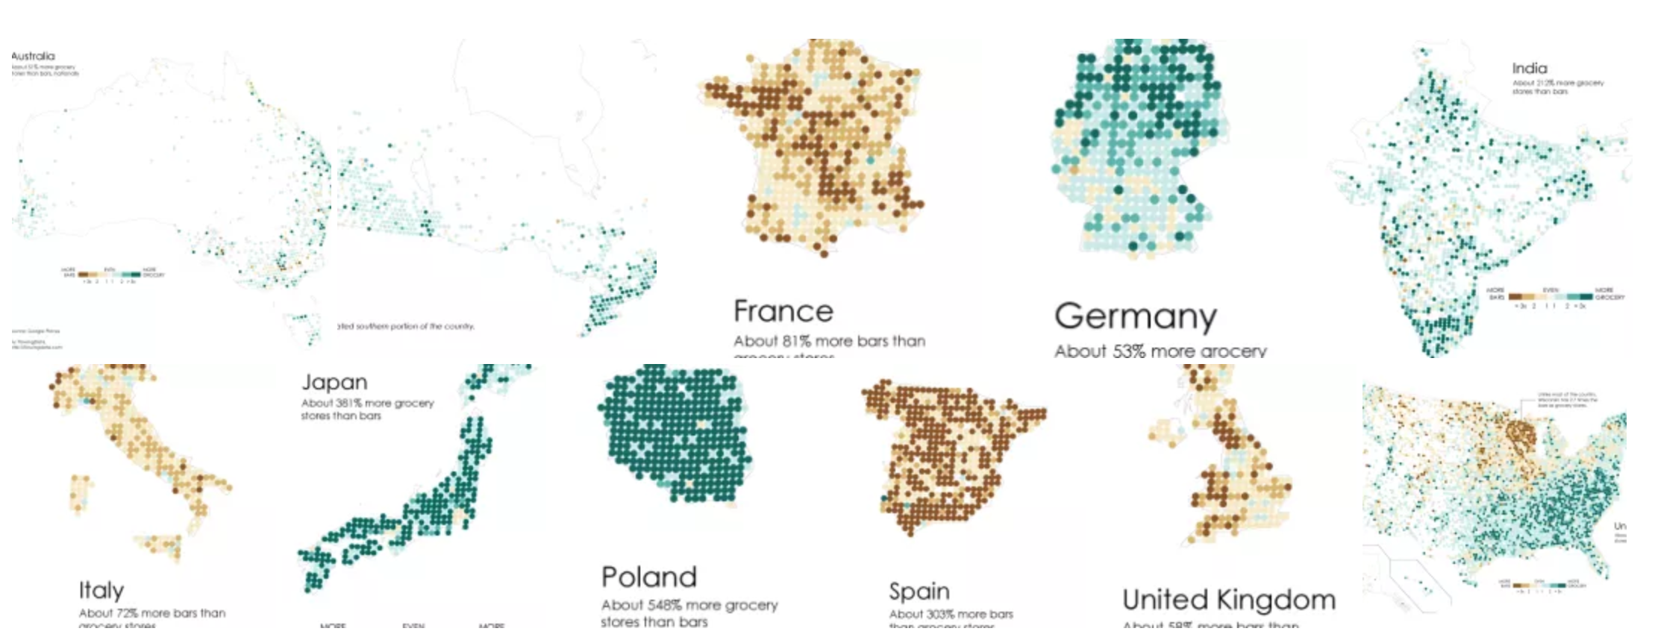

1. **From the**[**Revolution Analytics**](http://blog.revolutionanalytics.com/)**blog find a post that uses maps. Click on the graphics Category. Explain what the project was about and what data was used. Summarize the information being presented in the maps.**

Project Name: Is it faster to take a bike or taxi in NYC?

Project link: <http://blog.revolutionanalytics.com/2017/10/bokes-taxis-nyc.html>

Chart Type used: Dot Map - Each dot represents a data point. Collectively, geographic patterns emerge.

About the Project: This project is aimed at comparison of travel time for both Taxis and Citi bikes in NYC. The Author has built an interactive guide that shows when a Citi Bike is faster than a taxi in New York city, depending on the route and the time of day. [()](http://toddwschneider.com/posts/taxi-vs-citi-bike-nyc/)

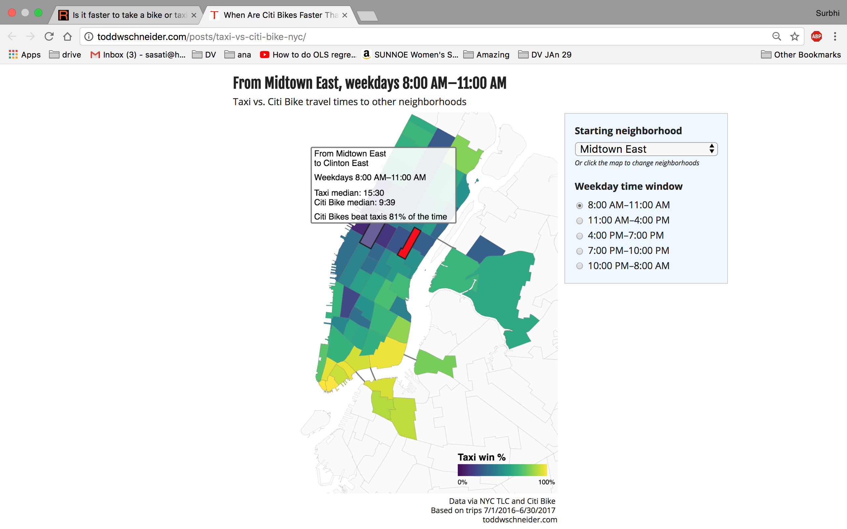

Data Used:

[Taxi trip data](http://www.nyc.gov/html/tlc/html/about/trip_record_data.shtml) is available since January 2009, [Citi Bike data](https://www.citibikenyc.com/system-data) since July 2013

Taxi data: <https://github.com/toddwschneider/nyc-taxi-data>

Citi bike data: <https://www.citibikenyc.com/system-data>

Summary:

The project is focussed on finding who’s the fastest between cars and bikes in New York City from July 1, 2016 to June 30, 2017—the filtered dataset that is restricted to weekday trips only. It is implemented using Monte Carlo simulation in R to calculate the probability that a Citi Bike would be faster than a taxi for a given route. The Author estimated that 40% of weekday taxi trips within the Citi Bike service area would expect to be faster if switched to a Citi Bike, based on data from July 2016 to June 2017. During peak midday hours, more than 50% of taxi trips would expect to be faster as Citi Bike rides. It was evident from the results that Crosstown Manhattan trips would best be taken with bikes.

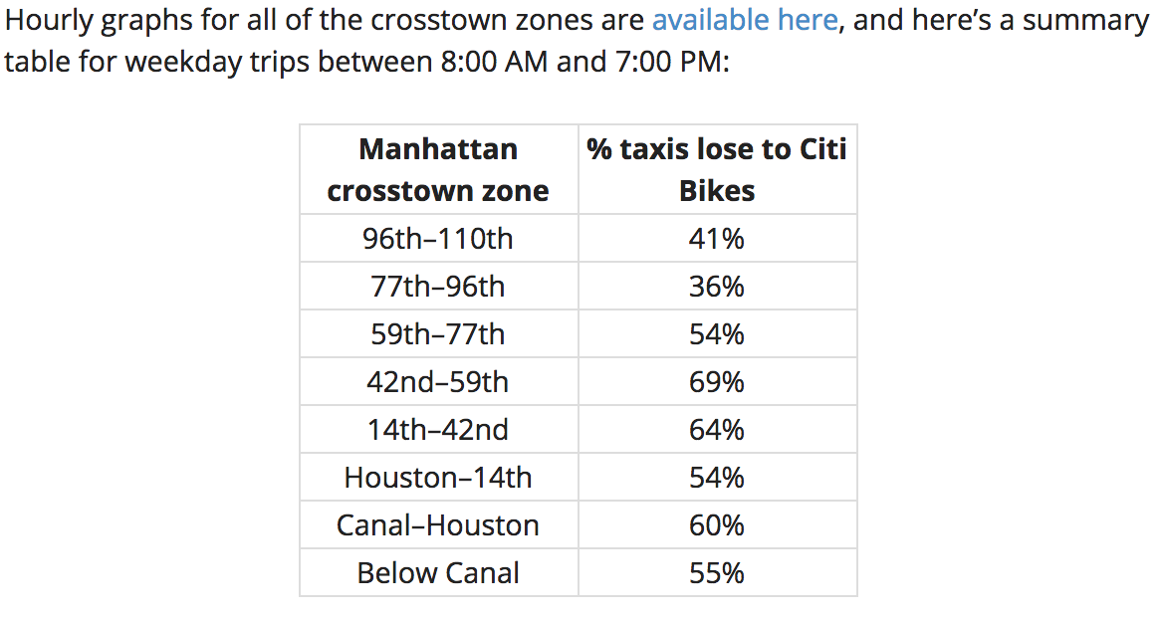

Taxis are losing more to Citi Bikes over time because taxi travel times have gotten slower, while Citi Bike travel times have remained roughly unchanged. Bike usage in New York has increased dramatically over the past decade though, the data shows that a lot of people could still save precious time if they switched from cars to bikes.

1. **Find a dataset of interest to you. First find a data source. Then download the data. Open the data in the visualization software. Make a map if you have the location or geolocation data. Or make some other kind of visualization. Comment about what your visualization is try to communicate.**
   1. **Make a plot of your data on a map using Google Charts (this is from Google Sheets in Google Docs).**

World Population Map in the Year 2015:

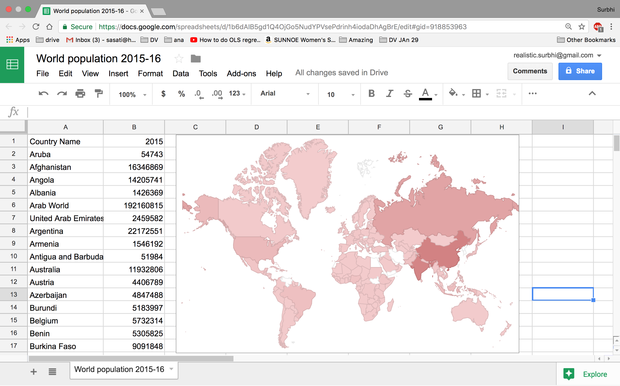

* 1. **Make the same plot of your data in Tableau.**

World Population Map in the Year 2015:

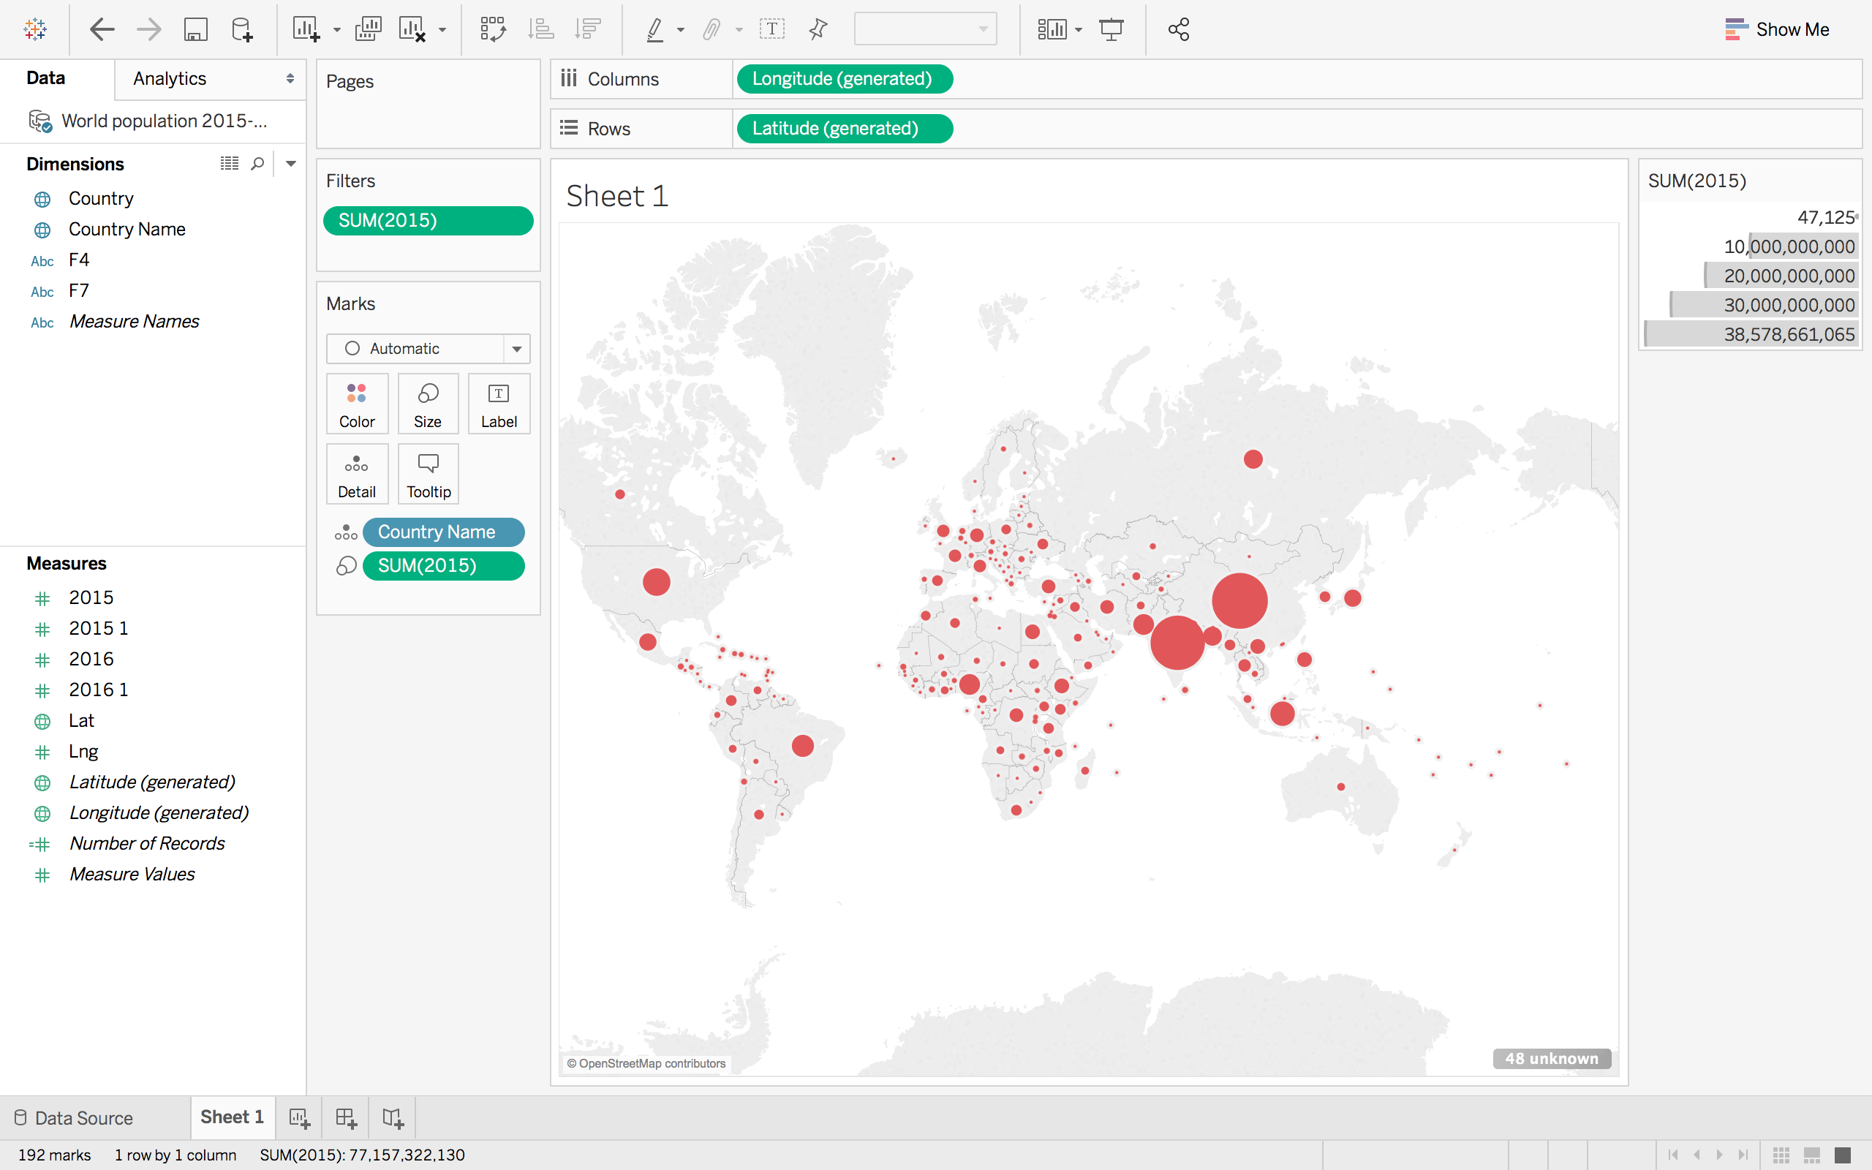

1. **Install the Quandl library in R. Find an interesting dataset from Quandl and make a time series plot in R.**

Data Source: <https://fred.stlouisfed.org/series/DEXUSEU>

U.S. / Euro Foreign Exchange Rate:

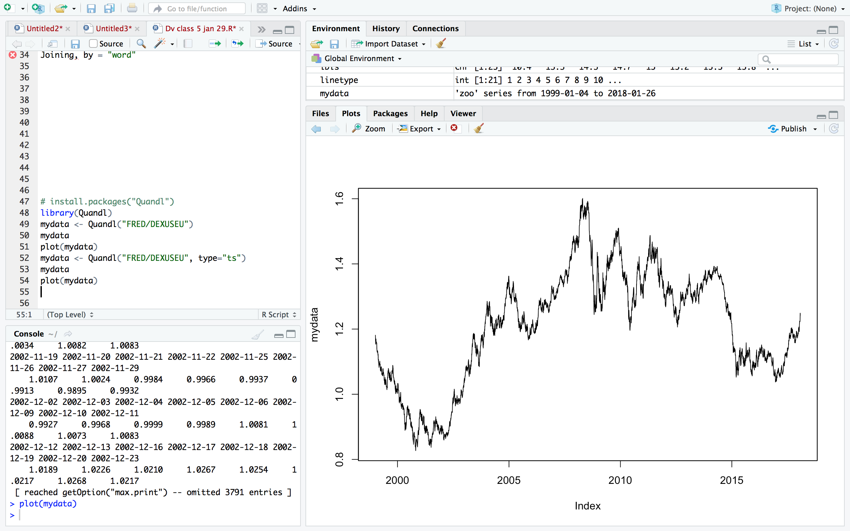

1. **Using R run the mtcars examples from the end of the**[**Tools**](http://www.sci.csueastbay.edu/~esuess/classes/Statistics_6610/viz/viz5/Tools.html#/)**presentations. Show the plots you have created in your homework document.**

